EFFECT OF AUSTENITIZATION AT 920 °C ON THE MECHANICAL PROPERTIES AND MICROSTRUCTURE OF MICROALLOYED STEEL

Mirko Gojić¹, *Gorazd Kosec², *Franc Vodopivec³, *Stjepan Kožuh¹, *Jelena Vojvodič Tuma³, *Aleš Nagode⁴, *Borut Kosec⁴

¹University of Zagreb, Faculty of Metallugy, Aleja narodnih heroja 3, 44103 Sisak, Croatia, gojic@simet.hr, kozuh@simet.hr
²ACRONI d.o.o.,c. Borisa Kidriča 44, 4270 Jesenice, Slovenia, gorazd.kosec@acroni.si
³Institute of Metals and Technology, Lepi pot 11, 1000 Ljubljana, Slovenia, franc.vodopivec@imt.si, jelena.tuma@imt.si
⁴University of Ljubljana, Faculty of Natural Sciences and Engineering, Aškerčeva cesta 12, 1000 Ljubljana, Slovenia, borut.kosec@omm.ntf.uni-lj.si, ales.nagode@omm.ntf.uni-lj.si

In this paper the effect of heat treatment on mechanical properties and microstructure for microalloyed high-strength low-alloy (HSLA) steel is investigated. Austenitization of the steel samples was performed at 920 ºC for 15 minutes. After austenitization the quenching procedure was carried out in both, hot water (at 70 °C) and lead bath at 400 ºC, following by cooling on air. Tensile strength, hardness and Charpy impact energy are tested. Microstructural analysis was carried out using optical and scanning electron microscopy (SEM). Values of tensile strength were in the range from 1160 to 1824 MPa, while values of hardness were in the range from 205 to 282 HV5. The microstructure of base material consisted of acicular ferrite and degenerated pearlite. The quenching in water from 920 ºC produced a coarse microstructure with platelets of ferrite and lath primary martensite. The cooling in lead bath from 920 ºC to 400 ºC produced microstructure consisted from ferrite and bainite. Fractography analysis by SEM method showed that cleavage fracture occurred.

Key words: microalloed steel, heat treatment, mechanical properties, microstructure

INTRODUCTION

Microalloyed high strength low alloy (HSLA) steels represents very important group of steels for different fileds application (pipelines, offshore platforms, ship building, reservoir for liquid natural gas etc.). These steels are used for petrochemical vessels because of its excellent weldability and resistance to hidrogen embrittlement (HE). They contains a small amaunts of microalloying such as Nb, Ti, V to attain high yield strengths in the as rolled condition [1]. The main properties of HSLA steels are: high yield and tensile strength, good toughness at low temperatures, resistance to stress corrosion cracking and on hydrogen embritlement, good cold working, weldability etc. [2]. It known that the toughness and transition temperature is very important for these steels because of that Charpy impact energy is highly dependent on the microstructure [3,4].
In the previously published paper it was found that Charpy impact energy is higher and the transition temperature is lower for the transformation of austenite to bainite than to martensite microstructure [5,6]. The aim of this research was to determinate effect of austenitization of microalloyed steel at 920 ºC and cooling at different conditions on mechanical properties and microstructure of microallying steel.

MATERIAL AND METHODS OF WORK

The high strength low alloyed (HSLA) structural steel was used for this investigation. Chemical composition of the steel presented in Table 1. Microalloying elements niobium and titanium are used for control of the austenite grain size and improving mechanical properties.

Table 1. Chemical composition of the steel, wt. %
C | S | Al | Ni | Cr | Si | Mn | P | Cu | Mo | Ti | Nb
0.11 | 0.004 | 0.019 | 0.15 | 0.54 | 0.36 | 0.50 | 0.012 | 0.29 | 0.34 | 0.014 | 0.032

Temperatures phase transformation were determined by dilatometer method (Bähr – Geratebau GmbH, type T 805) at heat rate of 30 K/s. Heat treatment of specimens consisted from austenitization and rapid cooling as well as austenitization and izothermal cooling. The first group specimens was austenitized at 920 ºC for 15 minutes and queched in the hot water at temperature of 70 ºC. Another group of specimens were austenitized at 920 ºC for 15 minutes and izothermal cooled in lead bath up to 400 ºC folowed cooling in water. Mechanical properties are tested at room temperature. Yield strength and tensile strength were tested by means of strip specimens on Zwick Z250 N5A tensile machine. Hardness testing was performed by Vichers method (HV5). Impact energy was tested by Charpy method using ISO V-notch. Microstructural analysis was carried out using optical and scanning electron microscopy (SEM). Preparing specimens for metallographic analysis was carried on clasical way (grinding and polising) using etching in nital solution. Fractography anlysis was performed by SEM Jeol JSM 5610.

RESULTS AND DISCUSSION

From microalloyed steel after heat treatment is expected high strength, toughness and good weldability. It is known empiric equations for calculation of temperature phase transformation on the basis chemical composition of steel:

A_{C1} = 723 – 10.7 Mn – 16.9 Ni + 29.1 Si + 16.9 Cr (1)
A_{C3} = 910 – 203 √C – 15 Ni + 44.7 Si + 31.5 Mo (2)

Using above equations the theoretic tmperatures of phase transformations for this steel are: Ac₁=734.7 ºC and Ac₃=867.2 ºC. Temperature phase transformations for this steel measured at heat rate of 30 K/s are: Ac₁=757 ºC and Ac₃=861 ºC. The difference between calcualated and measuremented values is 6.2 ºC. On the basis measured temperature fase transformation determined is heat treatment which consisted from austenitization at 920 ºC and different colling conditions. As result of this the microstructure (Figs. 1-3) and mechanical properties (Table 2) are changed. The microstructure of the as delivered steel consisted of acicular ferrite and degenerated pearlite (Figure 1). This pearlite can be formed by nucleation of cementite at austenite/ferrite boundaries followed by carbide-free ferrite layers enclosing the cementite in the temparature range the formaation of conventional lamellar pearlite and upper bainite [7]. After water quenching from 920 °C a microstructure consisted from coarse ferrite matrix with martensite grains and small amounts cementite (Figure 2). The quenching in lead bath from 920 °C produced a microstruture of coarse ferrite and bainite (Figure 3). It can be seen that mechanical properties (Table 2) are closely associated with the microstructure of the steel. The lowest values of tensile strength and hardness are obtained in delivered state of the steel. By quenching in water tensile strength is important incresed from 1052 MPa to 1824 MPa, while hardness was increased from 205 HV5 to 282 HV5. Simultenously Charpy impact energy is decreased from 240 J up to 126 J. After after austenitization at 920 ºC and lead bath cooling at 400 ºC Charpy impact energy is incresed up to 252 J. Microfractographies of fracture surfaces made on broken tensile test samples are shown in Figures 4-6. As can be seen that clevage mechanism of fracture was observed. After quenching from 920 ºC in water the clevage facets were coarser but phase boundary between ferrite and martensite are not source expanding cleavage microcraks (Figure 5). Into clevage facets the rivers patterns and microckecks were observed. The rivers are not straight as the boundaries of platelets of ferrite, it assumed that the increased number of rivers is due to propagation of the microcracks trough the microstructure consisting of platelets of ferrite and stringers of cementite particles. In the case clevage fracture models for low carbon high strength steel the fracture takes place when the stress field in the region ahead of the peak stress achieves the clevage stress of the steel at a characteristic distance [8]. As nucleation places for clevage initiation on the fracture surfaces can serve any particles (inclusions, carbides etc.). The path of clevage microcracks and their propagation is on carbide/ferrite or carbidemartensite interfaces [9].

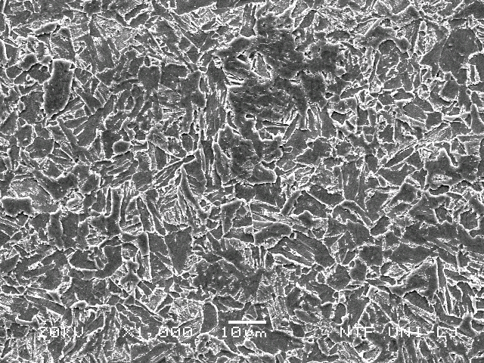

Figure 1. Microstructure of the steel in delivered state

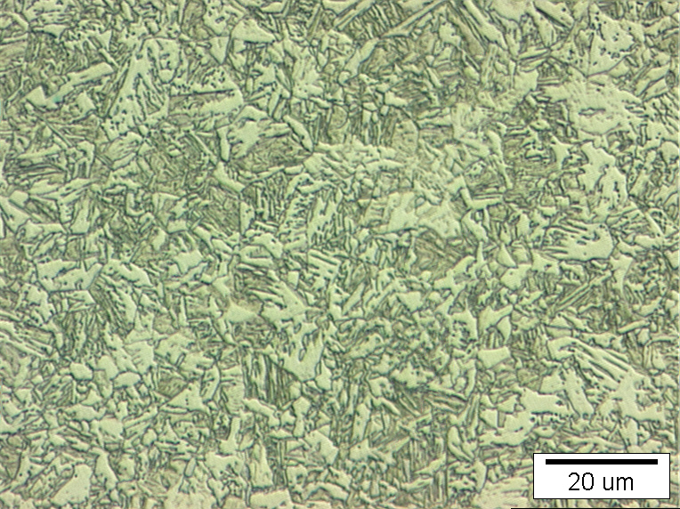
(a)
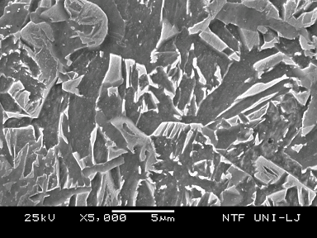
(b)

Figure 2. Microstructure of the steel after austenitization at 920 ºC and quenching in water
Obtained by optical (a) and scanning electron microscopy (b)

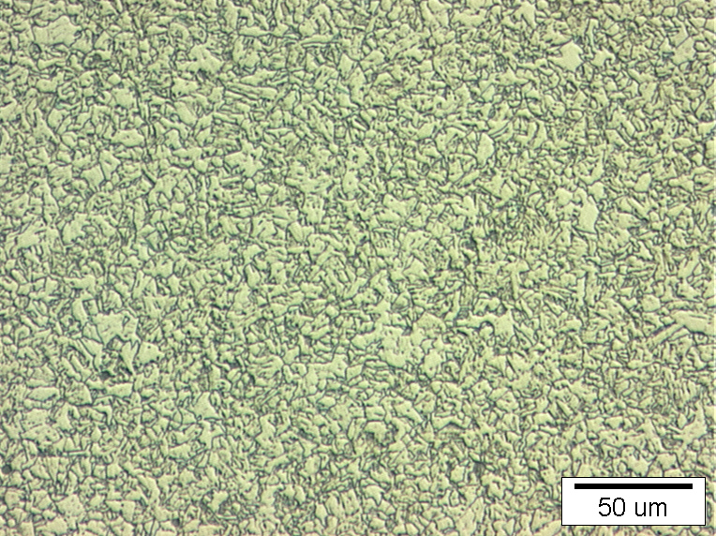

Figure 3. Microstructure of the steel after austenitization at 920 ºC and lead bath
cooling at 400 ºC.

Table 2. Average values of mechanical properties of steel at different conditions
Heat treatment | Yield strength (MPa) | Tensile strength (MPa) | Hardness (HV5) | Charpy impact  energy (J)
As delivered | 1052 | 1160 | 205 | 240
920 ˚C/water | 1101 | 1824 | 282 | 126
920 ˚C/lead bath | 836 | 1389 | 222 | 252

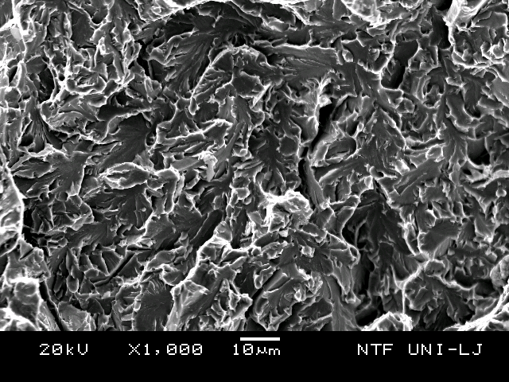

Figure 4. Microfractography of fracture surface of steel in delivered state after tensile test

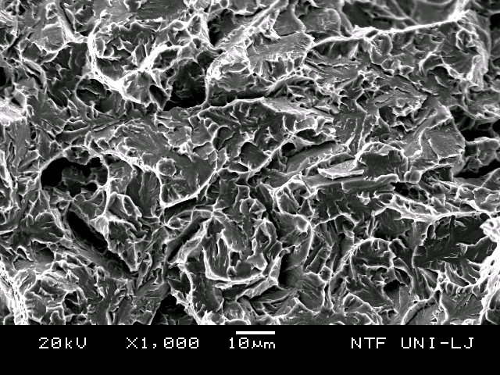

Figure 5. Microfractography of fracture surface of steel quenched from 920 ºC in water

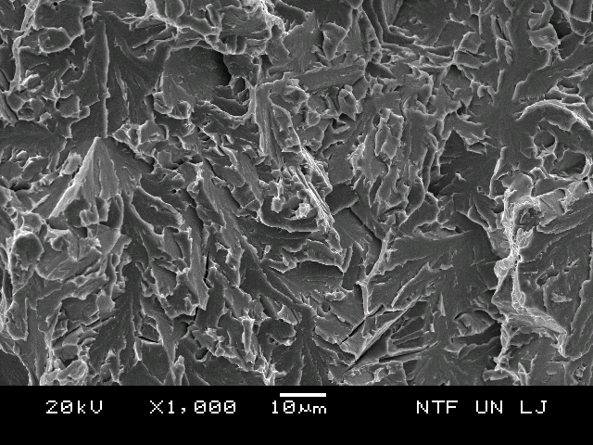

Figure 6. Microfractography of fracture surface of steel austentizing at 920 ºC and cooling from 920 ºC in lead bath up to 400 ºC

CONCLUSIONS

On the basis investigation of low carbon microalloying high strength steel (0.11C-0.34Mo-0.032Nb-0.014Ti) the following conclusion are presented:
- The microstructure of the steel in delivered steel consisted of acicular ferrite and degenerated pearlite with Charpy impact energy of 240 J.
- After water quenching from 920 ºC a microstructure consisted from coarse ferrite matrix with martensite grains and small amounts cementite with Charpy impact energy of 126 J. Values of tensile strength was 1824 MPa, while hardness was 282 HV5.
- By cooling in lead bath (400 ºC) from 920 ^{O}C microstruture consted from the coarse ferrite and bainite. It is resulsts with the tensile strength of 1389 Mpa, hardness of 222 HV5 and Charpy impact energy of 252 J.
- Fractography analysis of fracture surfaces made on broken tensile test samples showed the clevage mechanism of fracture. Into clevage facets the rivers patterns and microckecks were observed. As nucleation places for clevage initiation on the fracture surfaces possible cementite particles.

LITERATURE

[1] Mousavi Anijdan S.H., Yue S., Effect of ferrite deformation temperature on the mechanical properties of microalloyed steels, Materials Science and Engineering, A535 (2012), 84-91.
[2] Shukla R., Ghosh S.G., Chakrabarti D., Chatterjee S., Microstructure, texture. Property relationship in thermo-mechanically processed ultra-low carbon microalloyed ateel for pipeline application, Materials Science and Engineering, A587 (2013), 201-208.
[3] Wang B., Lian J., Effect of microstructure on low-temperature toughness of a low carbon Nb-V-Ti microalloyed pipeline steel, Materials Science and Engineering, A592 (2014), 50-56.
[4] Gutiérrez I., Effect of microstructure on the impact toughness of Nb-microalloyed steel: Generalisation of existing relations from ferrite-pearlite to high strength microstructures, Materials Science and Engineering, A571 (2013), 57-67.
[5] Vodopivec F., Šuštarčič B., Vojvodič Tuma J., Kosec G., Charpy notch toughness and hardness of reheated martensite and lower bainite, Metalurgija 42(3) (2010), 149-154.
[6] Kosec G., Vojvodič Tuma J., Gojić M., Nagode A., Stojić A., Samardžić I., Kosec B., Effect of heat treatment on Charpy impact energy of microaaloyed stee, Technical Gazette 23 (3) (2016), 761-767.
[7] Shanmugam S., Misra R.D.K., Mannering T., Panda D., Jansto S.G., Impact toughness and microstructure relationship in niobium and vanadium microalloyed steels processed with varied cooling rates to similar yield strength, Materials Science and Engineering, A437 (2006), 436-445.
[8] Betegon C., Belzunce F.J., Rodriguez C., A two parameter fracture criteria for high strength low carbon steel, Acta Materialia 44 (3) (1996), 1055-1061.
[9] Im Y.R., Lee B.J., Oh Y., Hong J.H., Lee M.C., Effect of microstructure on the clevage fracture strength oflow carbon Mn-Ni-Mo bainitic steels, Journal of Nuclear Materials 324 (2004), 33-40.

