ELECTROCONDUCTIVE COPPER POWDER FILLED PMMA COMPOSITES

M. G. Pavlović¹, M. M. Pavlović², M. Pantović², Z. Janković³,
R. Fuchs-Godec⁴, B. Malinović⁵

¹University of Eastern Sarajevo, Faculty of Technology Zvornik, Republic of Srpska
²University in Belgrade, NU ICTM-CEH, Njegoševa 12, Belgrade. Serbia
³V&Z Zaštita, d.o.o., B. Luka, Republic of Srpska, Bosnia and Herzegovina
⁴University of Maribor, Faculty of Chemistry and Chemical Engineering, Slovenia
⁵University of B. Luka, Faculty of Technology, Republic of Srpska, Bosnia and Herzegovina

ABSTRACT

This article is concerned with synthesis and characterization of electroconductive composite materials prepared by hot molding of mixtures of PMMA and electrochemically deposited copper powder and investigation of the influence of particle morphology on conductivity and percolation threshold of obtained composites and thermal characteristics. Electrodeposited copper powder content was varied from 0.5-8.8 vol%. Analysis of the most significant properties of individual components and prepared composites AFM and TGA analysis. The significant increase of the electrical conductivity can be observed as the copper powder content reaches the percolation threshold at 2.98 vol%. In the investigated range of electrodeposited copper powder concentrations the increase of the electrical conductivity of composites is as much as sixteen orders of magnitude.

INTRODUCTION

Properties of the composites are heavily influenced by properties of the starting constituent materials, their distribution, processing method and the interaction between them. The properties of the composite do not depend only on the concentration of filler, but also on size, shape (geometric ratio), interstitial interaction between filler and matrix and filler orientation [1,2].
Attempts to improve material properties by adding fillers, either inorganic or organic, are not new. For a long time synthetic polymer composites are used in various industrial fields, equipment, automotive industry, and even in the aviation industry.
Conductive or semiconductive polymer composites are widely studied because of their numerous high-tech, electrical and electronic applications in various fields, such as self-regulating heaters, electric and temperature regulators for device protection and materials for removal of electromagnetic/radio frequency interferences (EMI / RFI) in electronic devices [3,4]. Conductive polymer composites can be prepared by different techniques and with different materials [5-7].
It is well known that the electrical resistance of polymer composites do not increase linearly with the increase of electrically conducting filler, but there is a critical volume fraction of filler (percolation concentration) at which the resistance of material sharply decreases from insulating range to the values of semiconductors or metallic conductors [7]. For efficiency, but also in order to improve the processability and to reduce costs of processing, as well as other economic parameters, the amount of conductive phase needed to obtain materials with high conductivity should be as small as possible.

Experimental

In the experimental part of the work poly(methylmethacrylate) (PMMA) was used as matrix. PMMA used was commercial PMMA in form of beads, supplied by Sigma-Aldrich, having average molecular weight of M_{w} ~350000, with a density of 1.20 g / cm^{3,} and the electrical conductivity of about 10⁻¹² S / cm. Before use, the polymer was dried in a tunnel furnace at 60 °C in a controlled nitrogen atmosphere.
The electrolytic copper powder used in this study was galvanostatically produced as described in [7].
Polymer composites of PMMA filled with copper powder were prepared with the filler volume fraction from 0.5% (v/v) - 8.8% (v/v). All the samples were produced from thoroughly homogenized mixtures of powders.
SEM, EDS and AFM analysis of PMMA composites were examined in more detail.

Results and Discussion

Conductivity of the conductive polymer composites strongly depends on nature of contacts between the conductive filler elements. In order to achieve better electrical conductivity fillers highly developed free surfaces, are used. For this reason the copper powder was galvanostatically produced with distinct dendritic morphology, having high specific surface area, as shown in Figure 1.

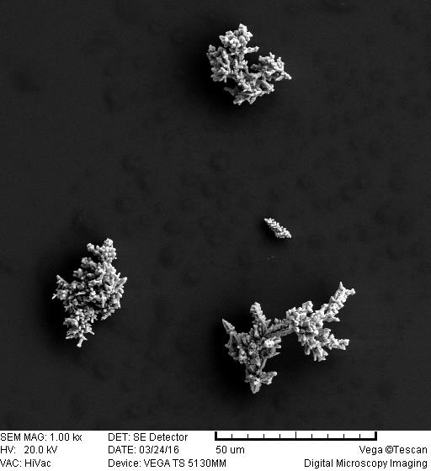

Figure 1. SEM photograph of copper powder particles obtained by constant current deposition and sieved through mesh <45 μm.

Presented results of copper powder morphological analysis showed that the powder has very large free surface. The powder shows specific characteristics typical of highly dendritic particles with distinctly developed primary and secondary dendritic arms with angles between them typical for centered cubic lattice. Therefore, this powder is a good prerequisite for the formation of great number of interpartical contacts between the conductive copper powder particles, hence decreasing percolation threshold.
Electrical conductivity of the composites, as a function of filler volume fraction, for all samples, was measured as mentioned in the Experimental part. DC I/O characteristics conductivity measurements for samples with a particle size ≤45 μm is shown in Figure 2. Typical S shaped dependence, with three different regions (insulating, transitional and conductive) can be observed. Percolation threshold value was obtained from the maximum of conductivity derivative as a function of volume fraction of filler.

Figure 2. Change in electrical conductivity as a function of filler volume fraction for PMMA composites filled with copper powder

Experiments have shown that the morphology of the particles plays a significant role for the percolation threshold appearance. Due expressed interparticle contact with small particles having a high specific surface area, and the impact of packaging phenomenom, the percolation threshold occurs at lower value of filler volume fraction for particles ≤45μm than stated in the literature [6]. As it can be seen in Figure 2, the percolation threshold was 2.98% (v/v), which is an improvement of over 10 times than stated in literature [6].

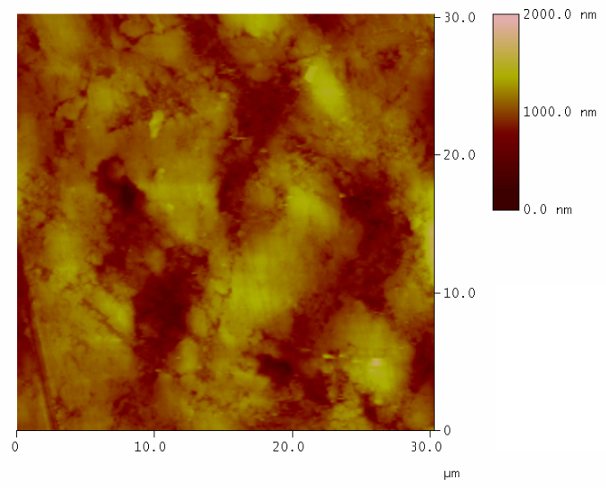
a)
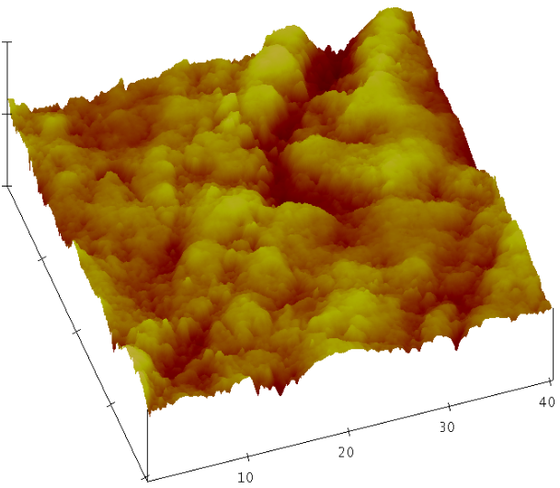
b)

Figure 3. AFM images of the PMMA composite filled with copper powder at percolation threshold. a) surface plot and b) top 3D view of the surface from a)

Figure 3 presents AFM image of the PMMA composite surface after breaking. Conductive pathways can be observed, where electrical conductivity of the composite is obtained through conductive pathways of the filler that form in the composites. These pathways are formed in 3D in a pure random order.

CONCLUSION

This article has shown the experimental study of deposited copper powder particles morphology effects on the electrical conductivity of the PMMA matrix composites filled with powder of this metal. The results showed that the morphology of the powder with a large specific surface area and a distinct dendritic features play an important role in the electrical conductivity of the prepared samples. Conductivity measurements have shown typical S shape dependence, with the percolation transition from non-conductive to conductive region. The effect of packaging and pronounced interpartical contact with smaller, highly porous, highly dendritic particles with a large specific surface area values has led to a "shift" of percolation threshold towards lower filler volume fraction values. For given range of filler volume fractions the increase in composites electrical conductivity was as much as 16 orders of magnitude. AFM measurements confirm the presence of conductive pathways in composite volume that are formed in 3D in a pure random order.
Acknowledgements
This work was supported by the Ministry of Education and Science of Republic of Serbia (Projects ON 172015 and ON 172046)

REFERENCES
- K. Mohanty, M. Misra, L. T. Drzal (Eds.), Natural Fibers, Biopolymers, and Biocomposites, Taylor and Francis Group, Florida, (2005).
- L. Averous, F. L. Digabel, Carbohydrate Polymers, 66(4), 480, (2006).
- V. H. Poblete, M. P. Alvarez, V. M. Fuenzalida, Polymer Composites, 30, 328, (2009).
- D. S. McLachlan., M. Blaszkiewicz, R. E. Newnham, Journal of the American Ceramic Society, 73(8), 2187, (1990).
- L. J. Huijbregts, Charge transport and morphology in nanofillers and polymer nanocomposites, Doctoral Disertation, Technische Universiteit Eindhoven, Eindhoven, (2008).
- G. Pinto, A. K. Maaroufi, Journal of Applied Polymer Science, 96, 2011, (2005).
- M. M. Pavlović, Sinteza i karakterizacija elektroprovodnih kompozitnih materijala na bazi biorazgradivih polimera i prahova metala, Doktorska disertacija, Univerzitet u Beogradu, Tehnološko - metalurški fakultet, Beograd, (2015).

