EFFECT OF CARAWAY ESSENTIAL OIL ON PORK COOKED SAUSAGE QUALITY

Branislav Šojić^{1*}, Vladimir Tomović¹, Natalija Džinić¹, Jovo Savanović², Danica Savanović³

¹Faculty of Technology, University of Novi Sad, Serbia
²MI ''DIM-DIM'' d.o.o., Laktaši, Bosnia and Herzegovina
³Faculty of Technology, University of Banja Luka, Bosnia and Herzegovina

*Corresponding author: E-mail address: bsojic@gmail.com (Dr Branislav Šojić)

The purpose of this study was to evaluate the effect of caraway essential oil (CO) on the quality of pork cooked sausages. Pork cooked sausages with different concentrations of CO (1, 2.5 and 5.0 µl/g) and control (without CO) were prepared. PH, thiobarbituric acid-reactive substance (TBARS) values and sensory panel scores have been assessed. The addition of CO had no significantly (p>0.05) effect on pH values of pork cooked sausages. The addition of CO (all three concentrations) significantly (p<0.05) decreased TBARS values compared to control. The flavor of sausages produced with the addition of 1 µl/g CO were moderate/large difference (p<0.05) compared to control. This study shows the significant antioxidant activity of caraway essential oil, as well as potential of its utilization in production of pork cooked sausages to enhance quality.

Key words: caraway essential oil; pork cooked sausage; quality

INTRODUCTION

Cooked sausages represent the most popular type of meat products, making up even 50% of the total industrial production of meat in Serbia [1, 2].
Variability of raw materials (meat, spices and other ingredients), high temperatures in thermal treatment, as well as, different storage conditions, affect chemical [3, 4], microbiological [5] and sensory degradation [3] of cooked sausages.
One of the most common causes of chemical degradation is lipid oxidation [2, 6]. Lipid oxidation leads to negative changes in color, flavor, taste and texture, as well as to a decrease in the nutritional value of the product [3, 7].
Antioxidants are used in order to reduce the lipid oxidation. Due to potentially toxic and carcinogenic effects of synthetic antioxidants (BHT, BHA), numerous studies have been focused at research on natural antioxidants [2, 4, 8, 9, 10].
The most commonly used natural antioxidants in meat products are essential plant oils and herbal extracts. Numerous studies shown that essential oils, owing to different volatile, natural, aromatic compounds, beside antioxidant possess also, antimicrobial and anti-inflammatory properties [11, 12].
Caraway has been used in traditional medicine (for treatment of opportunistic infections), as a spice, in folk medicine and in the pharmacy and food industries. The major components in the composition of the caraway essential oil are oxygenated monoterpenes [13]. Caraway essential oil also contains other active components which exhibit antiradical activity against the DPPH radical and contribute to the reduction of the lipid peroxidation [13, 14].
Hence, the aim of this study was to assess the effects of different concentrations (1.0-5.0 µL/g) of caraway essential oil addition on antioxidant activity in pork cooked sausages. PH and sensory characteristics of color and flavor were also determined.

MATERIAL AND METHODS

Preparation of cooked sausage
Cooked sausages were produced in local industrial plant. The main mixture consisted of meat from pork shoulder (14.0 kg), pork back fat (5 kg), pork skin emulsion (5 kg), ice water (4.5 kg), textured soy protein (0.6 kg), nitrite salt (0.54 kg) and spice mix (Lay Gewurze OHG, Germany) (0.25 kg). The minced meat was mixed with all other ingredients in a bowl chopper (Taifun 200, Nowicki, Poland) to obtain sausage batter. Caraway essential oil (CO) was purchased from Herba doo (Belgrade, Serbia).
CO was added to the sausage batters at concentration of 1.0 µL/g (CO1), 2.5 µL/g (CO2) and 5.0 µL/g (CO3). The sausage batter without caraway essential oil addition was used as control. All batches were stuffed into artificial cellulose casings (diameter of 40mm) and pasteurized (in steam at 75°C) until an internal temperature of 72°C was reached. Immediately after the heating process sausages were cooled and stored in cooling chamber (to 4°C) until analysis.
Processing was repeated three times for each batch (control, CO1, CO2 and CO3).

PH determination
The pH of samples was measured using the portable pH meter Testo 205 (Testo AG, USA) equipped with a combined penetration tip with temperature probe. PH was measured on three samples from each batch in duplicate.

TBARS determination
TBARS (2-thiobarbituric acid reactive substances) test was performed according to the method of Bostoglou et al. [15], with modifications described in Šojić et al. [2]. TBARS values were expressed as milligrams of malondialdehyde per kilogram of sample (mg MDA/kg). TBARS test was performed on three samples from each batch in duplicate.

Difference-from-control test
The difference-control-test was carried out by 7 trained assessors, who were able to discriminate samples in relation to the investigated attributes (color and flavor). The test consisted in the presentation of the control sample, followed by presentation of five coded samples with different concentrations of CO, in random order. Panelists were asked to evaluate the control sample first and then to determine how different the other coded samples were from the control one by rating this difference on a scale from 0 to 6, where 0 = no difference; 1 = very slight difference; 2 =slight/moderate difference; 3 = moderate difference; 4 = moderate/large difference; 5 = large difference; and 6 = very large difference [16].

Statistical analysis
Statistical analysis was carried out using STATISTICA 12.0 (StatSoft, Inc., Tulsa, OK, USA). All data were presented as mean value with their standard deviation indicated (mean ± SD). Variance analysis (ANOVA) was performed, with a confidence interval of 95% (p< 0.05).
Means were compared by Duncan’s multiple range test.

RESULTS AND DISCUSSION

The effect of caraway essential oil (CO) on the pH values of cooked sausages is shown in figure 1.

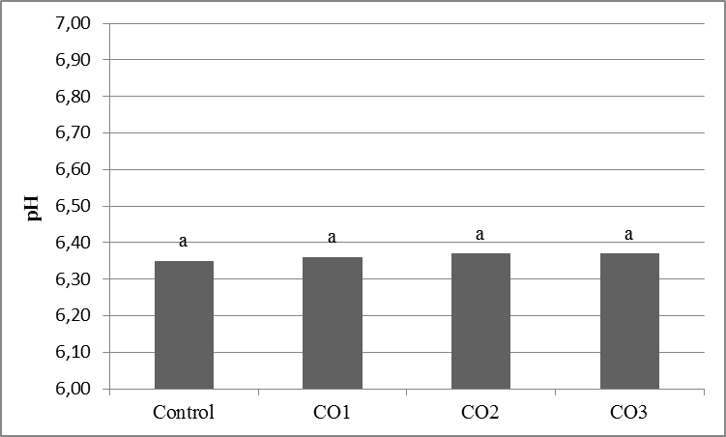
ª Means with different superscript letters differ significantly (p<0.05)
Figure 1. Effect of different concentrations of caraway essential oil (CO) on pH value of pork cooked sausages

The addition of CO had no significantly (p>0.05) effect on pH values of cooked sausages. PH values ranged from 6.35 (control) to 6.37 (CO2; CO3). Obtained results are in agreement with literature data for this type of sausages [12, 17].
Lipid oxidation was evaluated by determining the levels of TBARS (mg malondialdehyde/kg) (figure 2).

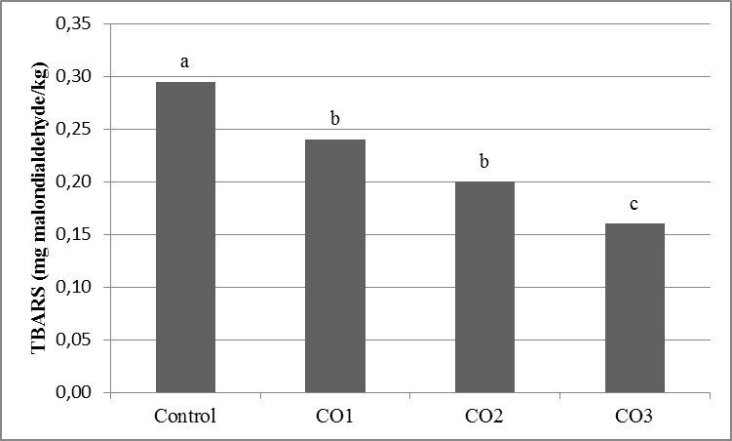
^{a–c} Means with different superscript letters differ significantly (p<0.05)
Figure 2. Effect of different concentrations of caraway essential oil (CO) on TBARS values (mg malondialdehyde/kg) of pork cooked sausages

The addition of CO (all three concentrations) significantly (p<0.05) decreased TBARS values compared to control. The reducing lipid oxidation in cooked sausages could be attributed to the presence of active phytochemicals in caraway essential oil [13, 14]. TBARS values were within a range of 0.16 (CO3) up to 0.30 mg MDA/kg (control). The obtained results very good corresponded with the literature data for similar products in the type of cooked sausages [2, 4].
Sensory panel results are shown in table 1.

Table 1. Effect of different concentrations of caraway essential oil (CO) on sensory properties of pork cooked sausages
Batch | Color | Flavor
Control | 0.14±0.38^{c} | 0.43±0.53^{c}
CO1 | 3.43±0.79ª | 3.86±1.07^{b}
CO2 | 3.29±0.95ª | 5.14±0.38ª
CO3 | 2.71±0.95^{ab} | 5.86±0.39ª
^{a–c} Means ± SD with different superscript letters in the same column differ significantly (p<0.05).

Sausages produced with the addition of CO were darker and redder compared to control. In this study, all three concentrations of CO significantly (p<0.05) influenced intensity of flavor. The addition of CO in concentrations of 1.0 affected to moderate/large differences of flavor. However, large difference to very large differences of flavor was observed for CO2 and CO3 comparing to control.

CONCLUSIONS

It can be concluded that the caraway essential oil, used in concentration of 1 µL/g (CO1) retarded lipid oxidation and improved color of cooked sausages, with moderate to large alteration of the original flavor of cooked sausages. Hence, caraway essential oil, such as natural plant material, could be successfully used as quality enhancer in pork cooked sausages.

Acknowledgements
This study was financially supported by Ministry of Education, Science and Technological Development, Republic of Serbia (TR31032).

LITERATURE

- Šojić, B., Petrović, Lj., Pešović, B., Tomović, V., Jokanović, M., Džinić, N. Salitrežić, P. The influence of inulin addition on the physico-chemical and sensory characteristics of reduced-fat cooked sausages. Acta Periodica Technologica, 42 (2011), 157–164.
- Šojić, B., Tomović, V., Kocić-Tanackov, S., Škaljac, S., Ikonić, P., Džinić, N., Živković, N., Tasić, T., Kravić, S. Effect of nutmeg (Myristica fragrans) essential oil on the oxidative and microbial stability of cooked sausage during refrigerated storage. Food Control, 54 (2015), 282–286.
- Hayes, J.E., Stepanyan, V., Allen, P., O’Grady, M.N., Kerry, J.P. Evaluation of the effects of selected plant-derived nutraceuticals on the quality and shelf-life stability of raw and cooked pork sausages. LWT - Food Science and Technology, 44 (2011), 164–172.
- Kulkarni, S., De Santos, F.A., Kattamuri, S., Rossi, S.J., Brewer, M.S. Effect of grape seed extract on oxidative, colour and sensory stability of pre-cooked, frozen, re-heated beef sausage model system. Meat Science, 88 (2011), 139–144.
- Sachindra, N.M., Sakhare, P.Z., Yashoda, K.P., Rao, D.N. Microbial profile of buffalo sausage during processing and storage. Food Control, 16 (2005), 31–35.
- de Almeida, P., de Lima, S., Costa, L., de Oliveira, C., Damasceno, K., dos Santos, B., Campagnol, P. Effect of jabuticaba peel extract on lipid oxidation, microbial stability and sensory properties of Bologna-type sausages during refrigerated storage. Meat Science, 110 (2015), 9–14.
- Qi, S., Zhou, D. Lotus seed epicarp extract as potential antioxidant and anti-obesity additive in Chinese Cantonese Sausage. Meat Science, 93 (2013), 257–262.
- Huang, B., He, J., Ban, X., Zeng, H., Yao, X., Wang, Y. Antioxidant activity of bovine and porcine meat treated with extracts fromedible lotus (Nelumbo nucifera) rhizome knot and leaf. Meat Science, 87 (2011), 46–53.
- Lorenzo, J.M., González-Rodríguez, R.M., Sánchez, M., Amado, I.R., Franco, D. Effects of natural (grape seed and chestnut extract) and synthetic antioxidants (buthylatedhydroxytoluene, BHT) on the physical, chemical, microbiological and sensory characteristics of dry cured sausage “chorizo”. Food Research International, 54 (2013, 611–620.
- Zhang, L., Lin, Y.H., Leng, X.J., Huang, M., Zhou, G.H. Effect of sage (Salvia officinalis) on the oxidative stability of Chinese-style sausage during refrigerated storage. Meat Science, 95 (2013), 145–150.
- Viuda-Martos, M., Ruiz-Navajas, Y., Fernández-López, J., Pérez-Álvarez, J.A. Antibacterial activity from different essential oil obtained from spices widely used in Mediterranean Diet. International Journal of Food Science and Technology, 43 (2007), 526–531.
- Viuda-Martos, M., Ruiz-Navajas, Y., Fernández-López, J., Pérez-Álvarez, J.A. Effect of adding citrus fibre washing water and rosemary essential oil on the qualitycharacteristics of a bologna sausage. LWT - Food Science and Technology, 43 (2010), 958–963.
- Samojlik, I., Lakić, N., Mimica-Dukić, N., Đaković-Švajcer, K., Božin, B. Antioxidant and Hepatoprotective Potential of Essential Oils of Coriander (Coriandrum sativum L.) and Caraway (Carum carvi L.) (Apiaceae). Journal of Agricultural and Food Chemistry, 58 (2010), 8848–8853.
- Krkić, N., Šojić, B., Lazić, V., Petrović, Lj., Mandić, A., Sedej, I., Tomović, V., Džinić, N. Effect of chitosan-caraway coating on lipid oxidation of traditional dry fermented sausage, Food Control, 32 (2014), 719–723.
- Botsoglou, N.A., Fletouris, D.J., Papageorgiou, G.E., Vassilopoulos, V.N., Mantis, A.J., Trakatellis, A.G. Rapid, sensitive and specific thiobarbituric acid method for measurement of lipid peroxidation in animal tissue, food and feedstuff samples. Journal of Agricultural and Food Chemistry, 42 (1994), 1931–193.
- Meilgaard, M., Civille, G., Carr, B. (Ed.): Sensory evaluation techniques, Taylor & Francis Group, New York (2006).
- de Oliveira, T., de Carvalho, S., de Araújo Soaresa, R., Andrade, M., das Graças Cardoso, M., Mendes Ramos, E., Piccoli, R. Antioxidant effects of Satureja montana L. essential oil on TBARS and colour of mortadella-type sausages formulated with different levels of sodium nitrite. LWT-Food Science and Technology, 45 (2012), 204–212.

